 | 26.14.14 Editors - Properties Editor - Object Data Properties Tab - Light Probe Object
Table of content
Light Probes 2
Reflection Cubemap 2
Reflection Plane 2
Irradiance Volume 2
Probe panel 2
Reflection Cubemap 2
Type 2
Radius 2
Falloff 3
Intensity 3
Clipping Start / End 3
Visibility 3
Visibility Collection 3
Reflection Plane 3
Distance 3
Falloff 3
Visibility 3
Visibility Collection 3
Irradiance Volume 4
Distance 4
Falloff 4
Intensity 4
Resolution X / Y / Z 4
Clipping Start / End 4
Visibility 4
Bias 5
Bleed Bias 5
Blur 5
Visibility Collection 5
Custom Parallax panel 5
Type 5
Radius 5
Viewport Display panel 5
Reflection Cubemap 6
Influence 6
Clipping 6
Parallax 6
Reflection Plane 6
Arrow Size 6
Influence 6
Show Preview Plane 6
Irradiance Volume 6
Influence 6
Clipping 6
Custom Properties Panel 6
Add 7
Edit 7
Remove 7

Light Probes

Probe objects are just useful for Eevee. Working with Light probes is a real time render technique. The light gets precalculated into a light probe object. And then used to light the scene indirectly.
There are three different probe types. Reflection Cubemap and Reflection plane is meant for specular lighting. Irradiance Volume for diffuse lighting.
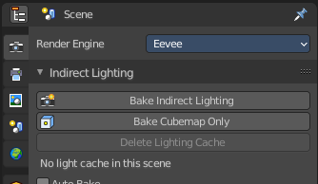
To work with the light probes you need to bake them. Baking lightpropbes happens in the render properties tab in the indirect lighting panel.

Reflection Cubemap
Adds a reflective light probe in cubemap shape.

Reflection Plane
Adds a reflective light probe in plane shape.

Irradiance Volume
Adds a volumetric array light probe.

Probe panel

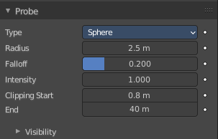
Reflection Cubemap

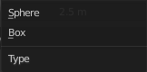
Type
The type of the influence volume.

Radius
A probe object only influences the lighting of nearby surfaces. This influence zone is defined by the Distance parameter and object scaling. The influence distance varies is a bit, depending on the probe type.
For Reflection Cubemaps the influence volume can either be a box or a sphere centered on the probe’s origin.

Falloff
Percentage of the influence distance during which the influence of a probe fades linearly.

Intensity
Intensity factor of the recorded lighting. Making this parameter anything other than 1.0 is not physically correct. Use it for tweaking or artistic purposes.

Clipping Start / End
Define the near and far clip distances when capturing the scene.

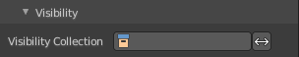
Visibility

Visibility Collection
Sometimes, it is useful to limit which objects appear in the light probe’s captured lighting. For instance, an object that is too close to a capture point might be better excluded. This is what the visibility collection does. Only objects that are in this collection will be visible when this probe will capture the scene.
There is also an option to invert this behavior and effectively hide the objects inside this collection.
Note! This is only a filtering option. That means if an object is not visible at render time it won’t be visible during the probe render.

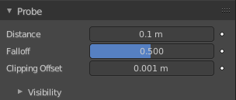
Reflection Plane

Distance
A probe object only influences the lighting of nearby surfaces. This influence zone is defined by the Distance parameter and object scaling. The influence distance varies is a bit, depending on the probe type.
For Reflection Planes the influence distance is the distance from the plane. Only surfaces whose normals are aligned with the Reflection Plane will receive the captured reflection.

Falloff
Percentage of the influence distance during which the influence of a probe fades linearly. Also defines how much shading normals needs to be aligned with the plane to receive reflections.
Clipping Offset
Define how much below the plane the near clip is when capturing the scene. Increasing this can fix reflection contact problems.

Visibility

Visibility Collection
In some cases, it is useful to limit which objects appear in the light probe’s captured lighting. For instance, an object that is too close to a capture point might be better excluded. This is what the visibility collection does. Only objects that are in this collection will be visible when this probe will capture the scene.
There is also an option to invert this behavior and effectively hide the objects inside this collection.
Note! This is only a filtering option. That means that if an object is not visible at render time it won’t be visible during the probe render.
Note! Due to a limitation, dupli-objects cannot be hidden by using this option.

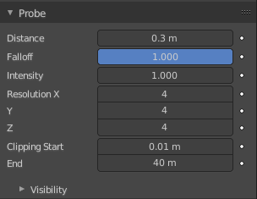
Irradiance Volume

Distance
A probe object only influences the lighting of nearby surfaces. This influence zone is defined by the Distance parameter and object scaling. The influence distance varies a bit, depending on the probe type.
For Irradiance Volumes, the influence inside the volume is always 100%. The influence decays only outside of the volume until the distance to the volume reaches the Distance parameter value (in local space).

Falloff
Percentage of the influence distance during which the influence of a probe fades linearly.

Intensity
Intensity factor of the recorded lighting. Making this parameter anything other than 1.0 is not physically correct. Use it for tweaking or artistic purposes.

Resolution X / Y / Z
Spatial resolution for Irradiance Volumes is determined per probe. The local volume is divided into a regular grid of the specified dimensions. One irradiance sample will be computed for each cell in this grid.

Clipping Start / End
Defines the near and far clip distances when capturing the scene.
Warning! Clipping distances are applied at the samples positions and not at the grid origin.

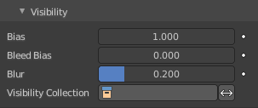
Visibility
For every grid point a small Variance Shadow Map is rendered. This visibility cubemap is used to reduce light leaking behind occluders. You can tweak the size of this map inside the render settings and tweak the bias and blur factors per grid inside the Probe Properties tab.

Bias
Reduces self-shadowing.

Bleed Bias
Increases the “contrast” of the depth test result.

Blur
Amount of blur to apply when filtering the visibility shadow map. Does not increase runtime cost but has a small effect on baking time.

Visibility Collection
In some cases, it is useful to limit which objects appear in the light probe’s captured lighting. For instance, an object that is too close to a capture point might be better excluded. This is what the visibility collection does. Only objects that are in this collection will be visible when this probes captures the scene.
There is also an option to invert this behavior and effectively hide the objects in this collection.
Note! This is only a filtering option. That means that if an object is not visible at render time it won’t be visible during the probe render.

Custom Parallax panel

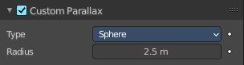
Reflection Cubemap only.
By default, the influence volume is also the parallax volume. The parallax volume is a volume on which is projected the recorded lighting. It should roughly fit it surrounding area. In some cases it may be better to adjust the parallax volume without touching the influence parameters. In this case, just enable the Custom Parallax and change the shape and distance of the parallax volume independently.

Type
The type of parallax volume.

Radius
The radius of the parallax volume. Measured by the lowest corner of the parallax bounding box.

Viewport Display panel
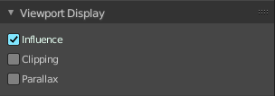

Reflection Cubemap

Influence
Show the influence bounds in the 3D Viewport. The inner sphere is where the falloff starts.

Clipping
Show the clipping distance in the 3D Viewport.

Parallax
Show the Custom Parallax shape in the 3D Viewport.

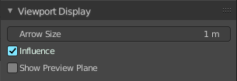
Reflection Plane

Arrow Size
Size of the arrow showing the reflection plane normal.

Influence
Show the influence bounds in the 3D Viewport.

Show Preview Plane
Show the captured reflected image onto a fully reflective plane in the 3D Viewport.

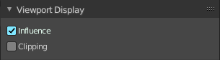
Irradiance Volume

Influence
Show the influence bounds in the 3D Viewport. The inner sphere is where the falloff starts.

Clipping
Show the clipping distance in the 3D Viewport.

Custom Properties Panel


Here you can define custom properties that can be used for scripting.

Here you might also find custom properties from addons or scripts.

Add
Adds a new property.


Edit
Opens a panel where you can adjust the settings for the custom property.

Remove
Removes the property.

